EXPERIMENT – 5
LIBRARY MANAGEMENT SYSTEM REQUIREMENT PRIORITIZATION (MoSCoW)

AIM
To categorize the requirements of a Library Management System using the MoSCoW method based on user and stakeholder impact, time, budget, and resource feasibility.

TOOLS USED
Microsoft Excel

PROCEDURE
1. Open Microsoft Excel and create a new workbook.
2. Create column headings: S.No, Requirement, MoSCoW Category, User / Stakeholder Impact, Feasibility, and Justification.
3. Enter all ten Library Management System requirements in separate rows.
4. Evaluate each requirement based on its impact on users, librarians, and administrators.
5. Assess feasibility based on the available time, budget, and development resources.
6. Categorize the essential requirements as Must-Have.
7. Categorize important but nonessential requirements as Should-Have.
8. Categorize desirable enhancements as Could-Have.
9. Categorize features deferred from the current release as Won’t-Have.
10. Write a brief justification for each categorization.
11. Apply appropriate formatting and colors to distinguish the four priority categories.
12. Review the completed worksheet and save the Excel file.

OUTPUT:
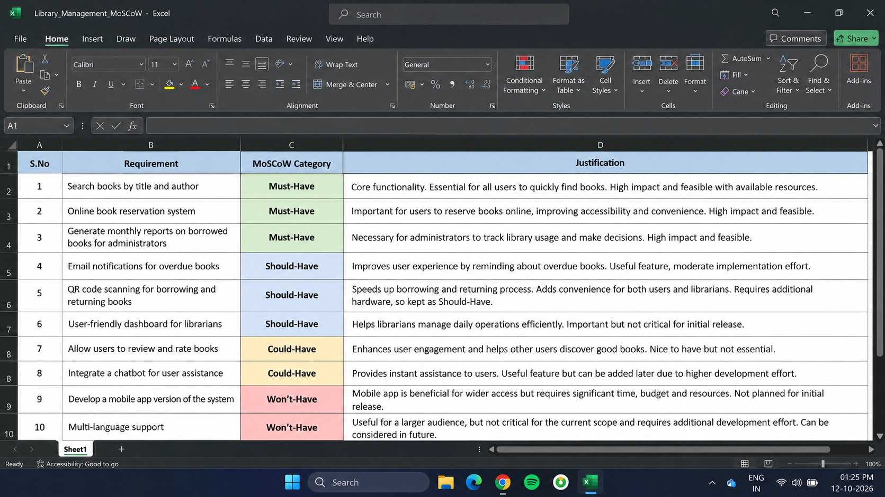
RESULT:
Thus, the ten requirements of the Library Management System were successfully classified and justified using the MoSCoW prioritization method in Microsoft Excel.

